The Easy Way to Fix Boring UIs

0:00
So, this is a pretty average nav design
0:02
that we see everywhere, but some users
0:04
may find it boring or too basic. To fix
0:07
this, all we need is a few shades of the
0:09
same color and then layer them like
0:11
this. The idea is pretty simple. We are
0:13
increasing the lightness value by 0.1
0:16
and then add the lighter color on top to
0:18
create a sense of depth. I have covered
0:20
these concepts in the colors video, so
0:22
feel free to watch it before or after
0:24
watching this video. But for now, let's
0:26
take things to the next level. Level one
0:29
would be a small shadow that is created
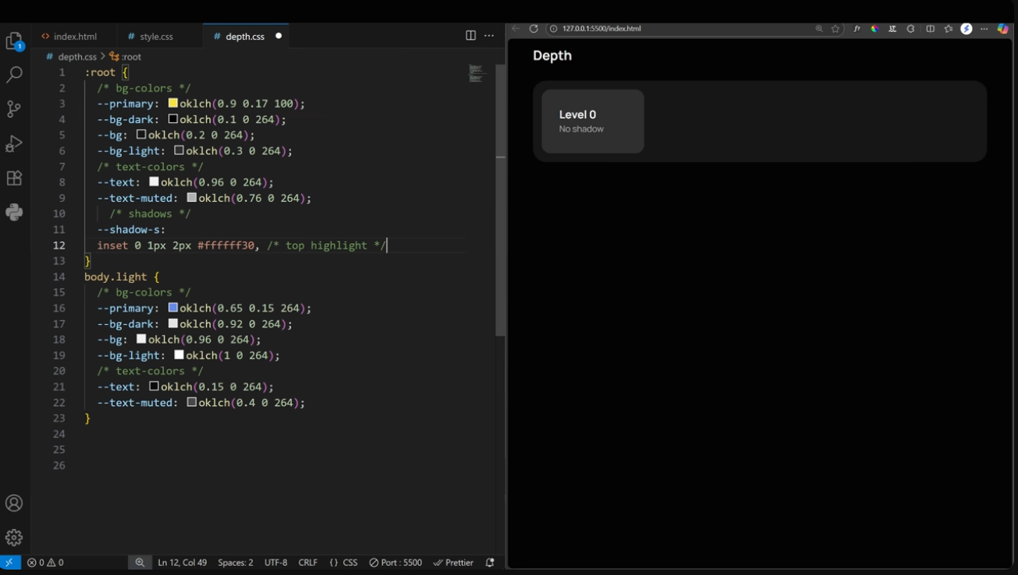
0:30
by adding a light border or glow on top
0:33
and then some dark shadow at the bottom.
0:35
Combining soft and dark shadows gives a
0:37
much more realistic feel than one basic
0:39
shadow. Then we can just bump these
0:41
values by a few pixels to add more
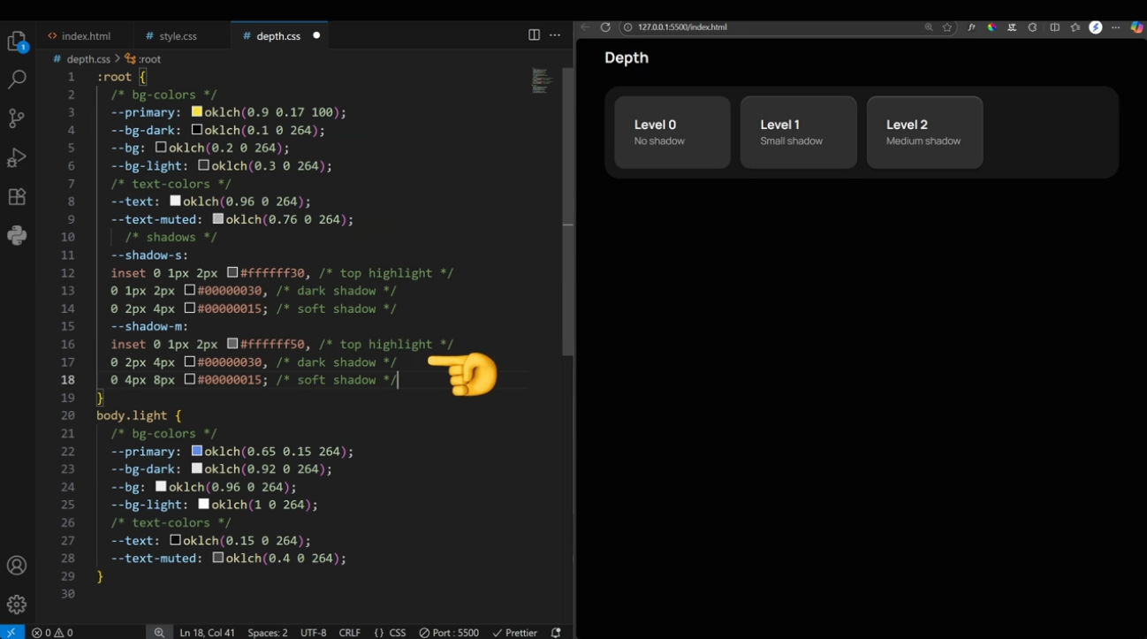
0:43
depth. These two shadows are enough for
0:45
most use cases, but you can always go
0:47
one level higher by pushing these values
0:49
by a few more pixels. Then it's up to
0:51
you to decide which shadow works best
0:53
for which element. For example, out of
0:56
these three shadows, the small one feels
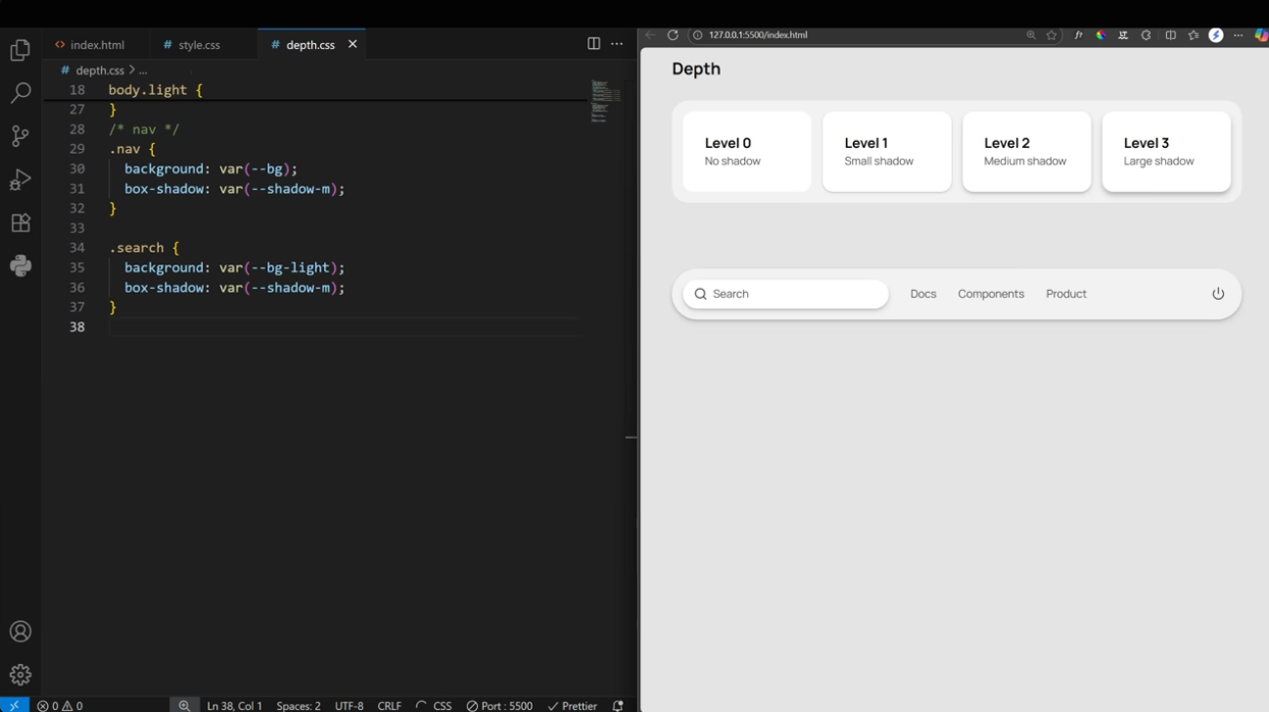
0:58
much more natural than the other. So, to
1:00
recap, it's a very simple two-step
1:02
process. First, create three to four
1:04
shades of the same color and then create
1:06
some shadows.
1:08
Now, start playing with depth. We have a
1:11
pretty standard profile card here.
1:13
Nothing wrong with it, but some may find
1:15
it a little boring. So, let's follow our
1:17
two steps. First, create layers by
1:19
adding a lighter color on important
1:21
elements. Then add the small shadow to
1:23
add more depth.
1:26
We can make it a bit more interesting by
1:28
adding a bigger shadow on hover. Works
1:30
best on light mode. The default theme
1:32
for most people. So never ignore light
1:35
mode just because you never use it. Now
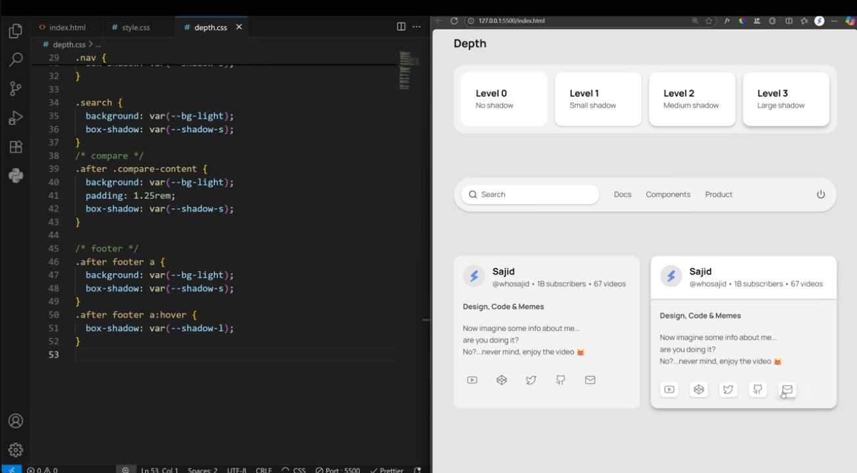
1:37
that we have the basics down, let's fix
1:39
some boring UIs. We are going to start
1:41
with this clean and simple design and
1:43
increase the complexity as we move
1:45
forward. As always, we start by adding a
1:48
background color that's a bit lighter
1:49
than the page itself. Then let's
1:51
highlight the selected tab by adding a
1:53
lighter shade, but that's made the text
1:55
and icon color a bit muted. So, we got
1:57
to increase the lightness on those two
1:59
as well. Again, if this seems a bit
2:01
confusing, I highly recommend watching
2:03
the colors video. Now, let's highlight
2:06
these drop downs as well as they are the
2:08
main elements of this UI. This is
2:10
already working, but we can add more
2:12
depth by combining a gradient with a
2:14
lighter inner shadow on top. The shiny
2:16
highlight up top complements these kinds
2:18
of linear gradients really well. like as
2:20
if the light coming from the top and
2:22
that's why the top part is lighter than
2:24
the bottom. But this was too easy to
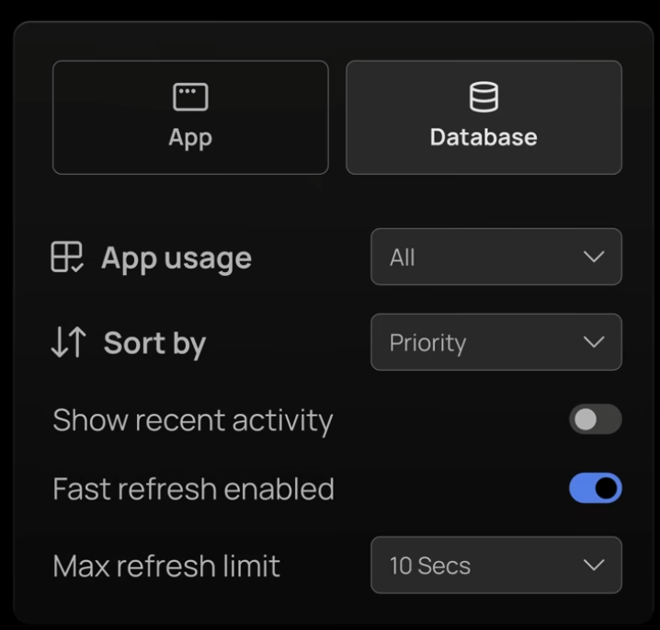
2:26
fix. Let's try a very common and boring
2:28
UI element radio buttons. First of all,
2:32
we are going to wrap everything inside a
2:34
lighter card. Then highlight the options
2:36
and add a bit of spacing. Also, we need
2:39
to emphasize the selected option as
2:41
well. Now, let's improve the typography
2:43
and rearrange things to create
2:45
hierarchy. The design can be further
2:47
improved by adding a bit more depth to
2:49
the selected card. This is the same
2:51
small shadow we used in the beginning
2:53
where we used a light inset shadow up
2:55
top and a dark shadow at the bottom.
2:58
Again, we are trying to sell the effect
2:59
of light hitting this card because it's
3:01
elevated and closer to the user making
3:04
it more important. This is a pretty
3:06
brilliant technique in UI design. You
3:08
know who else is Brilliant? The sponsor
3:10
of this video. Brilliant is a learning
3:12
app designed to be uniquely effective.
3:14
Each lesson is filled with hands-on
3:16
problem solving that lets you play with
3:18
concepts, a method proven to be six
3:21
times more effective than watching
3:22
lecture videos. Brilliant starts you
3:24
with mastering the foundations, then
3:26
helps you level up to increasingly
3:28
challenging problems. It has a perfect
3:30
mix of engaging problems, competitive
3:33
features, and daily encouragement that
3:35
keeps you motivated and on track. Plus,
3:37
all content on Brilliant is crafted by
3:39
an award-winning team of teachers and
3:41
professionals from top tier
3:42
institutions. Whether you're learning to
3:44
code, build formulas, design electrical
3:47
circuits, run simulations, or explore
3:49
cuttingedge topics like AI, you can try
3:52
it all for free. Just visit
3:54
brilliant.org/sided
3:56
or scan the QR code on screen or click
3:58
on the link in the description.
4:00
Brilliant's also given our viewers 20%
4:02
off an annual premium subscription,
4:04
which gives you unlimited daily access
4:06
to everything on Brilliant. So, here is
4:09
Before and after of last UI we did.
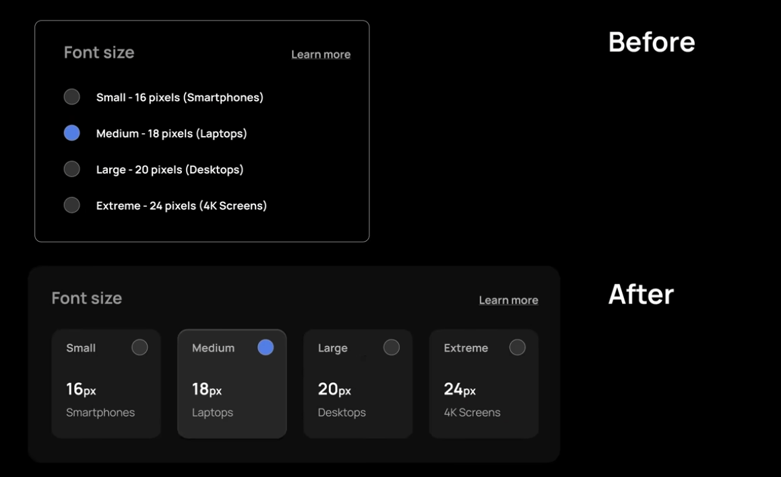
4:11
Now let's do some in light theme as
4:13
well. This is kind of overall big
4:15
picture UI. Again, pretty familiar and
4:18
basic style. A sidebar, two cards on top
4:21
that contains big and bold text. Then
4:23
some kind of graph and finally a table.
4:26
Right now everything is kind of blending
4:28
in together. There is no hierarchy.
4:30
Let's choose a darker shade for the
4:32
background and leave these four main
4:34
elements as it is. And immediately these
4:36
four elements start popping off the page
4:38
like they want your attention. But
4:40
that's also the problem. So the next
4:43
step is to deemphasize few of them.
4:45
Let's start with this table at the
4:46
bottom. Then a bit darker shade for the
4:49
graph as well. But notice it's lighter
4:51
than the table. And because we are using
4:53
color to create different layers, we can
4:55
remove borders on the lighter elements.
4:57
We can create even more depth by adding
4:59
a small shadow on the smaller card and a
5:01
big shadow on the bigger one. Of course,
5:04
they could use the same shadow or the
5:06
smaller one have the big shadow
5:07
depending on the context. The main idea
5:10
is to raise or lower certain elements.
5:12
On that note, we can add a dark inset
5:15
shadow on top and a light inset shadow
5:17
at the bottom of the table, like if it's
5:19
deeper than everything else. We can also
5:22
add a slightly darker background color
5:23
to really sell this effect. And the
5:25
design is changed so much by just using
5:28
four shades of gray and some shadow. To
5:31
take it to the next level, try adding
5:33
some color. Of course, the color will
5:35
depend on the context, but most colors
5:37
will work if done correctly. Now let's
5:39
use whatever we have done so far and try
5:41
to fix this UI. Again, nothing wrong
5:44
with it. It's clean and simple, but just
5:46
too basic and maybe boring for some
5:48
users. We have a light background color.
5:51
Let's use it to create a darker and
5:53
lighter shade to create three shades in
5:55
total. As we have seen so far, we do
5:58
this to create layering of top, middle,
5:59
and bottom elements. Step one would be
6:02
to change the page color to bg dark as
6:04
it's the base for everything that comes
6:06
on top of it. Then we can separate these
6:08
three sections by applying the BG color.
6:11
Let's start with section one. Nice round
6:13
curves can make anything beautiful and
6:15
using BG light for the interactive
6:17
elements makes sense as they are the
6:19
elements that actually make this
6:20
interface. Finally, some shadow and we
6:23
can move on to section two. Round
6:26
corners, padding, and a shadow to start
6:28
things off. Now that we have a card, we
6:30
can rearrange some stuff to improve the
6:32
design. And if you notice, we have also
6:34
removed the border from the pro tag as
6:36
we can just use a lighter shade to
6:38
highlight it. So let's do the similar
6:40
thing with this progress bar to match
6:42
our overall design. If you notice, we
6:45
are using dark and light inset shadow to
6:47
push it into the card. So the actual
6:49
progress bar appears slightly elevated.
6:51
And while we are here, this text seems
6:53
important, but the typography is
6:55
lacking. So let's fix that as well.
6:58
Perfect. Let's move to the final
7:00
section. You might think there is little
7:03
to no room for improvement as they are
7:05
just two radio buttons. And why even
7:07
bother wasting time on this when you can
7:09
be designing or building much important
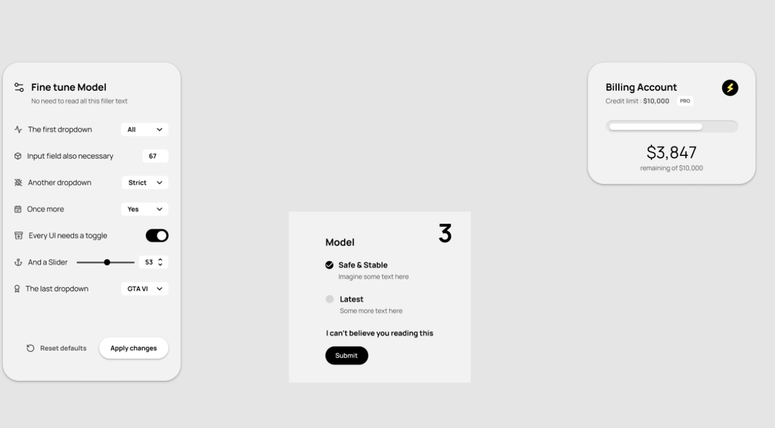
7:11
things. And I agree. Don't waste time
7:14
perfecting every little detail when the
7:16
outcome doesn't worth the effort. But
7:18
adding depth is so satisfying and
7:20
literally takes a few lines of code that
7:22
makes it worth it. Let's start by
7:24
highlighting both options. And as we did
7:26
earlier, we can do better than this
7:28
basic version. Why not add some icon to
7:31
complement the option? You can find
7:32
these anywhere online. All it takes is
7:35
one click to copy the SVG. Now, this
7:38
button feels out of place, so let's send
7:40
it to the right and use the same lighter
7:42
background to make it part of the
7:43
section. Also, this heading is not
7:46
necessary as this section is
7:47
self-explanatory.
7:50
Now, let's bring everything together to
7:51
see how they look as a whole UI.
7:54
This is nice, but let's expand the
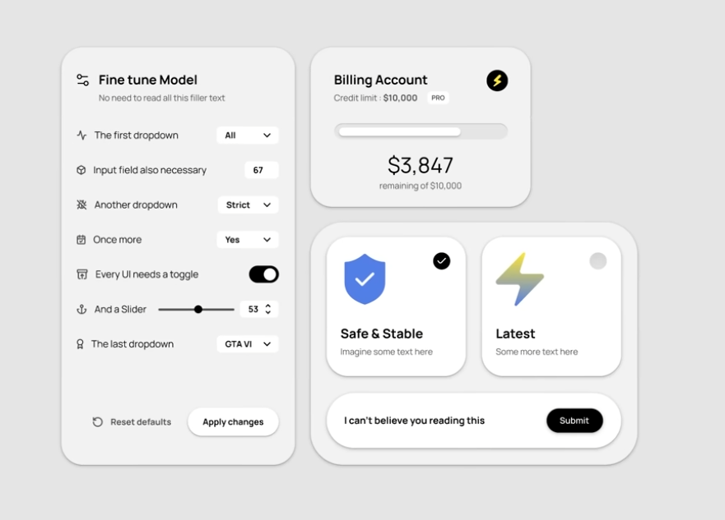
7:56
billing section to match the model
7:58
section. I hope you can see the night
8:00
and day difference between before and
8:02
after. Speaking of night and day, this
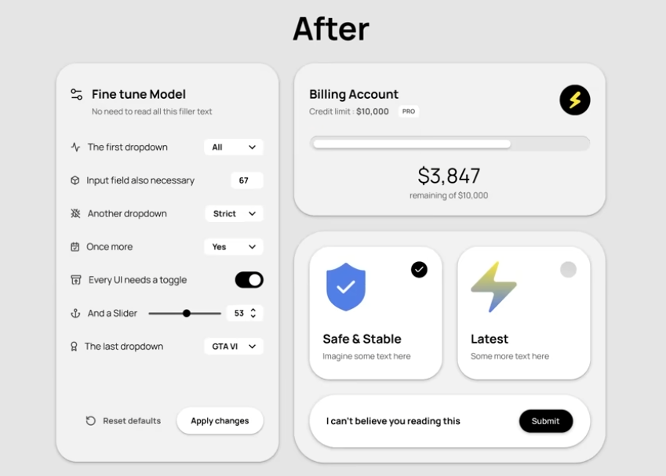
8:04
works on dark theme as well. And all the
8:06
dark theme examples we've seen earlier
8:09
will work on light theme as well. You
8:11
just need to use color and shadow
8:13
variables to assign background and box
8:15
shadows. Again, watch the colors video
8:17
if you haven't already. The idea is very
8:20
simple. You can turn an average design
8:22
to good design just by using depth. Of
8:25
course, we could have done tons of other
8:27
things to further improve the design,
8:29
but let me tell you a design secret. It
8:31
takes a lot less effort to take an
8:33
average design to good tier than it is
8:35
to take a good design to S tier. It's
8:38
kind of like how in video games there is
8:40
big graphics change when you go from
8:42
normal to high settings. But when you go
8:44
from high to ultra, there is a huge loss
8:46
in FPS, but you don't really see it in
8:49
graphics quality. The high setting is
8:51
the sweet spot for good graphics and
8:52
playable FPS. And as I shown in this
8:55
video, depth is that easy way to fix
8:57
boring UIs.

